**PASS User Manual**

1. **Login**

Log in through the login page (<https://sslab.ajou.ac.kr/pass/>).

1. **Assignments page**

You will see a list of PAs in the ***Assignments*** page. Click *Handout* to download the handouts (if applicable); Click *Submit* to test, or submit your PAs.

**2. Click to go to the Submission page**

**2. Click to go to the Submission page**

**1. Click**

**3. Submitting and Testing your PA**

The submission contains 3 blocks: ***Code,*** ***Report,*** and ***Git***. We will only use ***Code*** and ***Report*** in this course.

**3.1 Submitting your source code**

**1. Upload your source code**

**2. Run your program**

**3-2. Click to see test results.**

**3-1. Three possible execution results**

**3-4. Hints are given for failed tests.**

**3-3. Successful tests.**

**4. Your current submission is marked in red.**

**5. You can choose which submission you want to use for grading.**

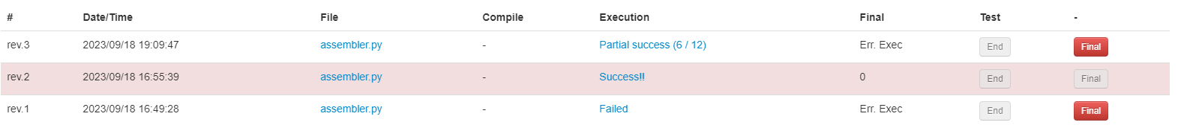

**6. Hooray! Perfect score!**

3.2 Submitting your report (if there is any)

**Upload your report here**